**SQL Server Integration Services (SSIS) Tasks (material taken from [1])**

In SSIS, control flow tasks help in defining a workflow for your package. When you open Control Flow design interface, the SSIS interface is populated with these tasks which you can drag and drop and configure as per your requirements. Let us now see some most important tasks that you might use in your routine work.

1. **File System Task**

The file system task can be used to perform various file operations, e.g.,

* Copy Directory: Copies all files from one directory to another. You must provide the source and destination directories.
* Copy File: Copies a specific file. You must provide the source and destination filename.
* Create Directory: Creates a directory. You must provide the source directory name and indicate whether the task should fail if the destination directory already exists.
* Delete Directory: Deletes a directory. You must provide the source directory to delete.
* Delete Directory Content: Deletes all files in a source directory
* Delete File: Deletes a specifically provided source file
* Move Directory: Moves a provided source directory to a destination directory. You must indicate whether the task should fail if the destination directory already exists.
* Move File: Moves a specific provided source file to a destination. You must indicate whether the task should fail if the destination file already exists.
* Rename File: Moves a specific provided source file to a destination by changing the name. You must indicate whether the task should fail if the destination file already exists.
* Set Attributes: Sets Hidden, Read-Only, Archive, or System attributes on a provided source file.

So how they are useful in the context of ETL? Suppose a collection of files are generated by a system on daily basis at a particular time. You can use File System Task to process these files and extracts data from them and then store it in SQL Server. After processing, the parsed files are then archived in a specific directory.

Now let us perform a simple File System Task. The task is related to move file from one path to another path. For this purpose please use the following steps

**Move File**

1. Launch Visual Studio 2019

2. Click on Create a Project

3. Select Integration Services Project from the list of types of projects, click Next

4. Name the project as FileSystemProject in the “Project Name” input box

5. Click “Create”. After this you will see the following SSIS workspace

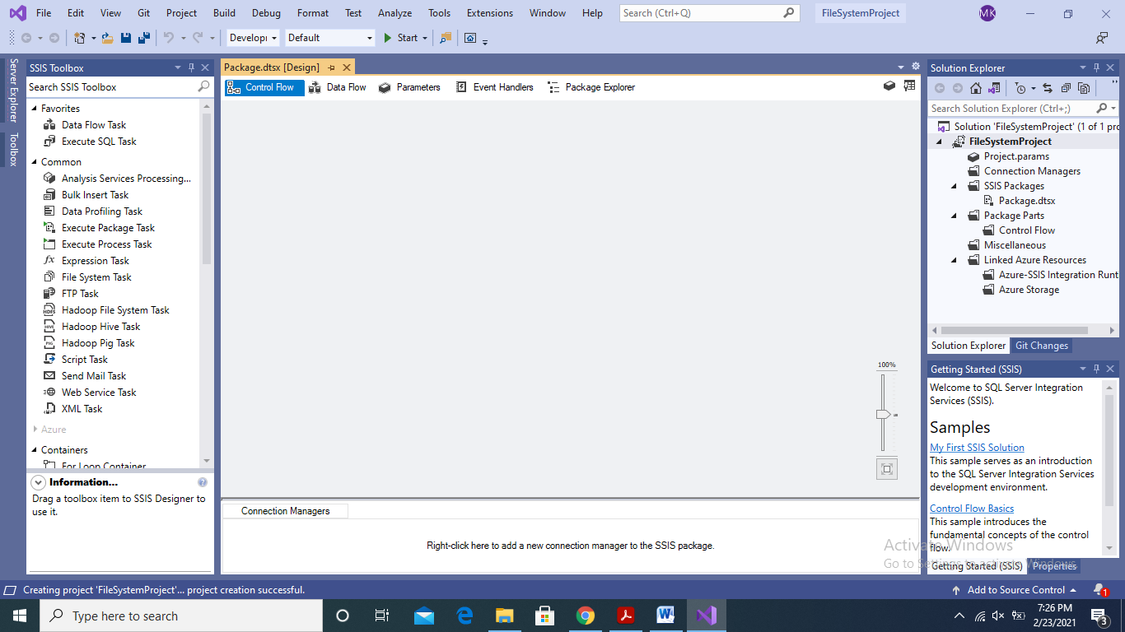

6. Next, from the SSIS Toolbox, select “File System Task” and drag it to the design space of Control Flow

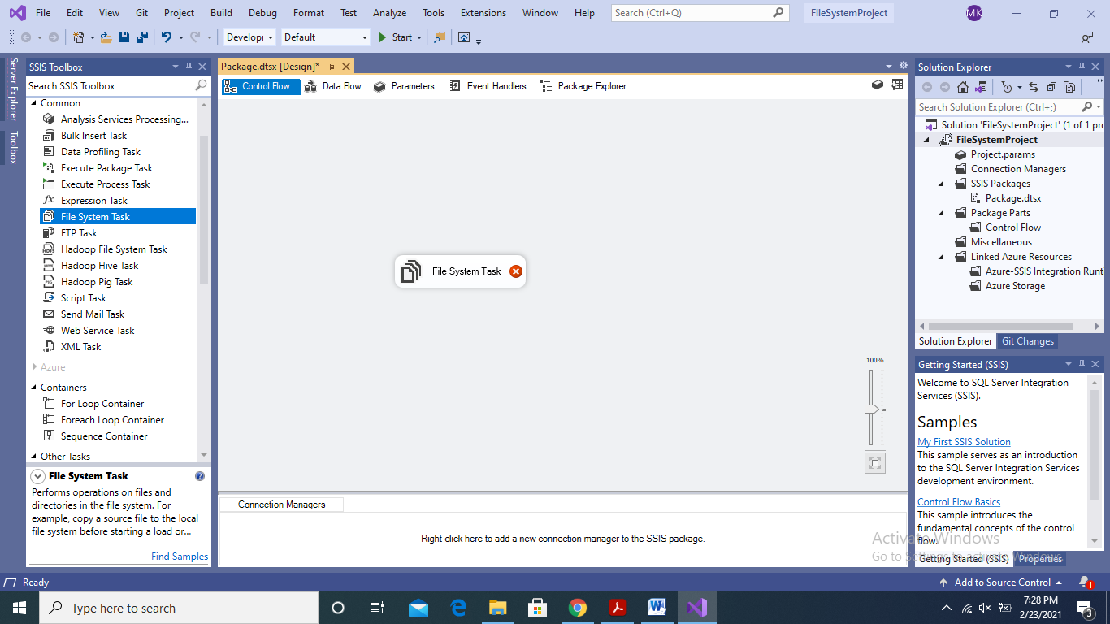

7. Next, create a subdirectory in your desired drive. In my case I have created a subdirectory with path as: D:\SSIS Repository. Next, make another subdirectory named “archive” in “SSIS Repository”

8. Next, create a dummy file in the above created directory as dummyFile.txt

9. Next, double click the File System Task that you dragged in the design space of Control Flow of SSIS. The following dialogue will open

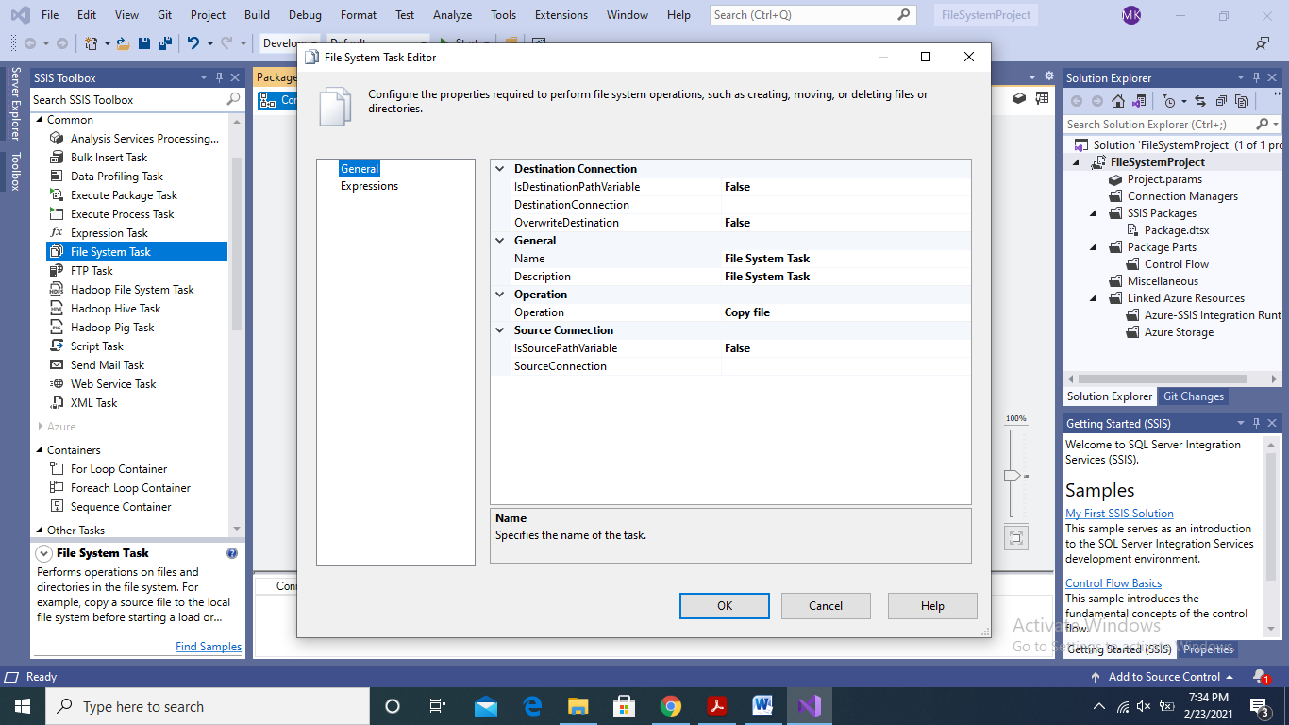

10. In the dialogue, change the “Operation” as “Move File”

11. Next, in the “SourceConnection” property select <New Connection..> from the drop down menu. This action will open the “File Connection Manager Editor” dialogue.

12. In the File Connection Manager Editor dialogue, select “Existing File” in usage type and then browse to give the path of the dummyFile.txt and clock “Ok”

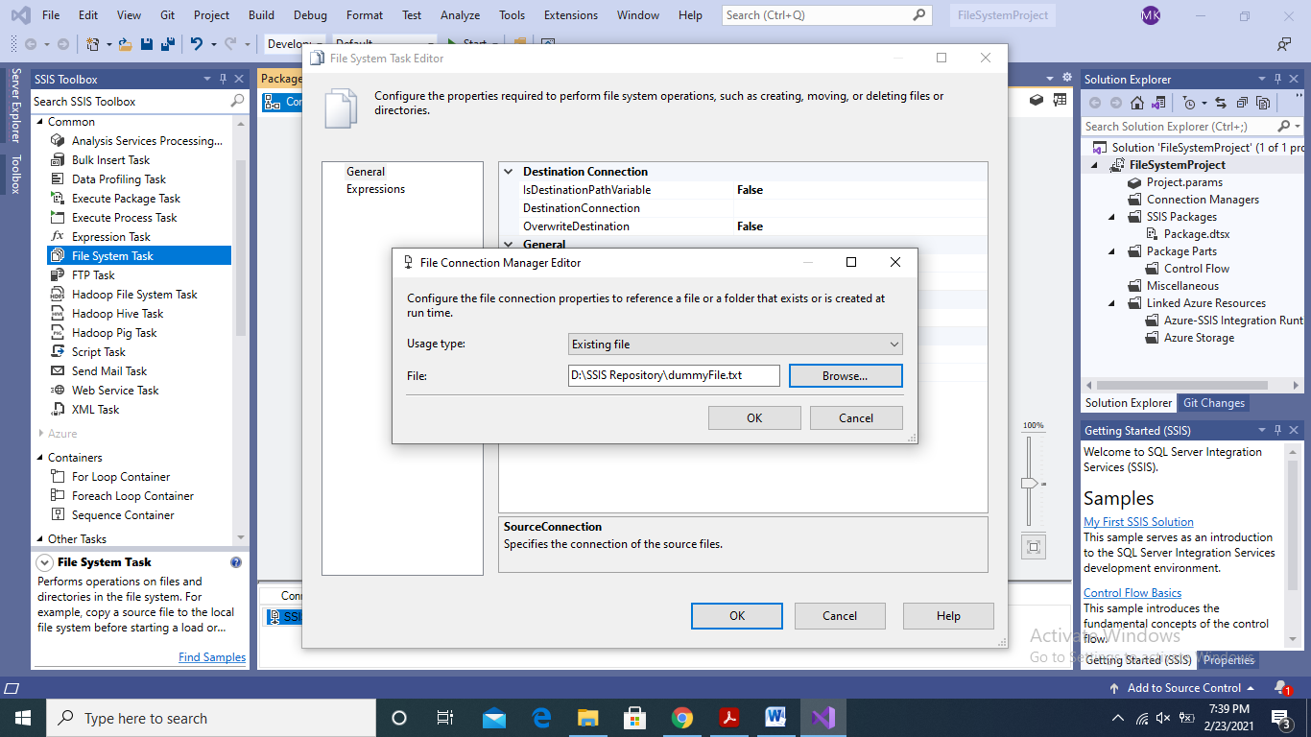

13. Next, in the File System Task Editor, select the <New Connection..> from the drop down menu in front of the “DestinationConnection” property. Once again “File Connection Manager Editor” will open.

14. In the File Connection Manager Editor, select “Existing Folder” in the Usage type drop down menu. Next, in the File path give the path of your archive folder which is a subfolder of SSIS Repository. Click Ok

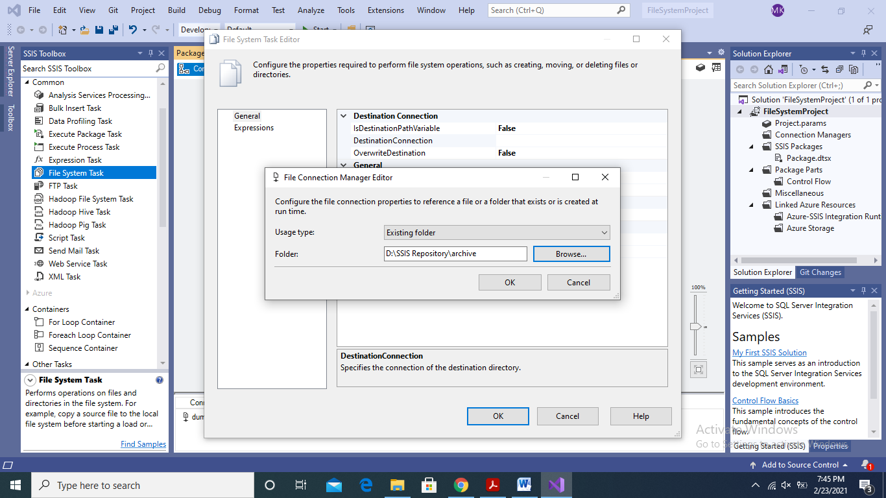

15. Click Ok on the File System Task Editor dialogue.

16. Next, run the package by clicking on the Start button on the top menu of the SSIS as shown in figure

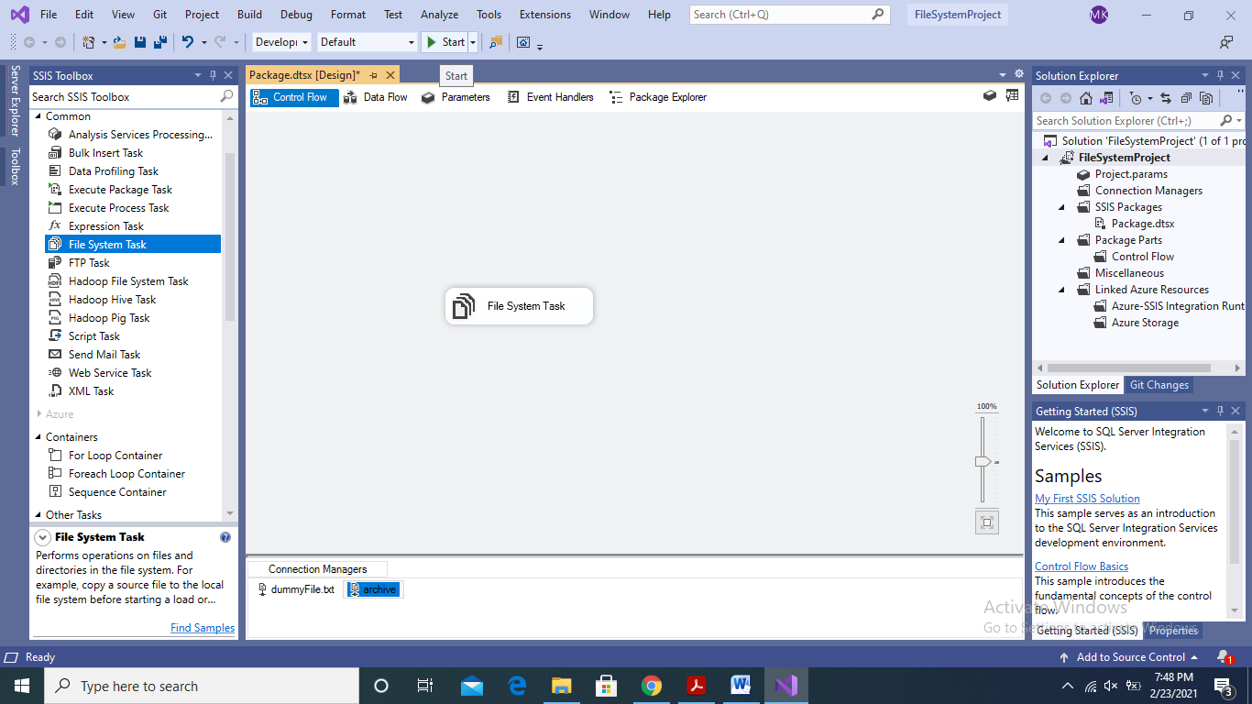

17. If the package executes successfully then you will see the moved file dummyFile.txt in the archive folder

**Rename File**

The rename file task will help in moving and renaming file in one task. For this purpose we need to define some variables

1. For renaming a file, we need to define variables. For this purpose, right click on the design space of the Control Flow. On the pop-up menu, select “Variables”. This will open a window to define variables as shown in figure

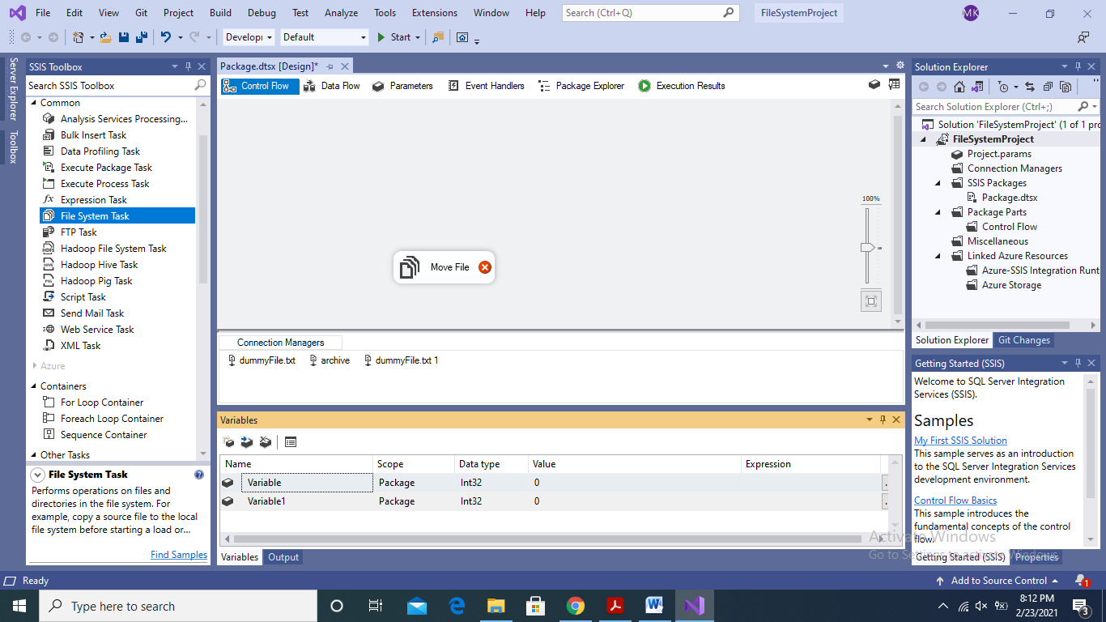

2. Define two variables as shown in the figure below

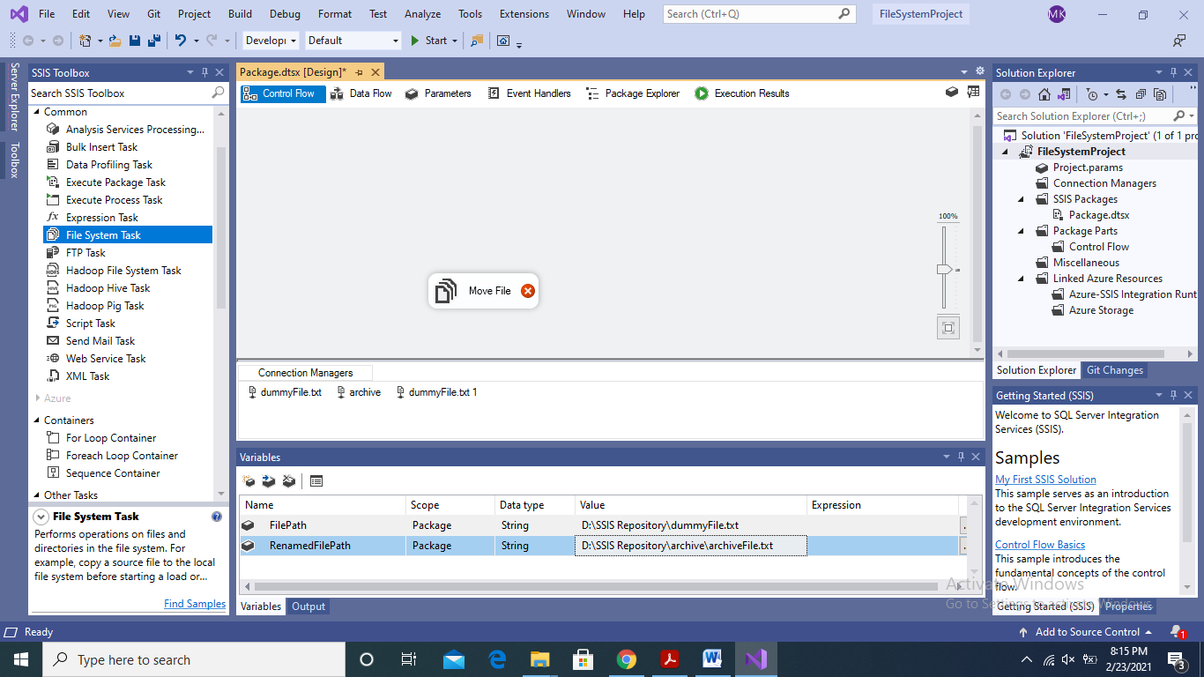

3. Next, double click the File System Task to open the File System Task Editor

4. Next, in the IsDestinationPathVariable, select True and in the DestinationVaraible select the RenamedFilePath variable that you defined in the previous step

5. Next, in the IsSourcePathVariable, select True and in the SourceVariable select FilePath variable that we defined earlier

6. Next, click Ok and run the package

7. If the package executes without error then you will see the moved and renamed dummyFile.txt in the archive sub-directory

1. **Execute Process Task**

The Execute Process Task is used to execute external programs that you can used in your ETL task

1. Drag and drop the Execute Process Task in the designer view of the Control Flow

2. Double click the Execute Process Task to open its configuration editor

3. In the executable, type notepad.exe. In the arguments give the path of the dummyFile.txt

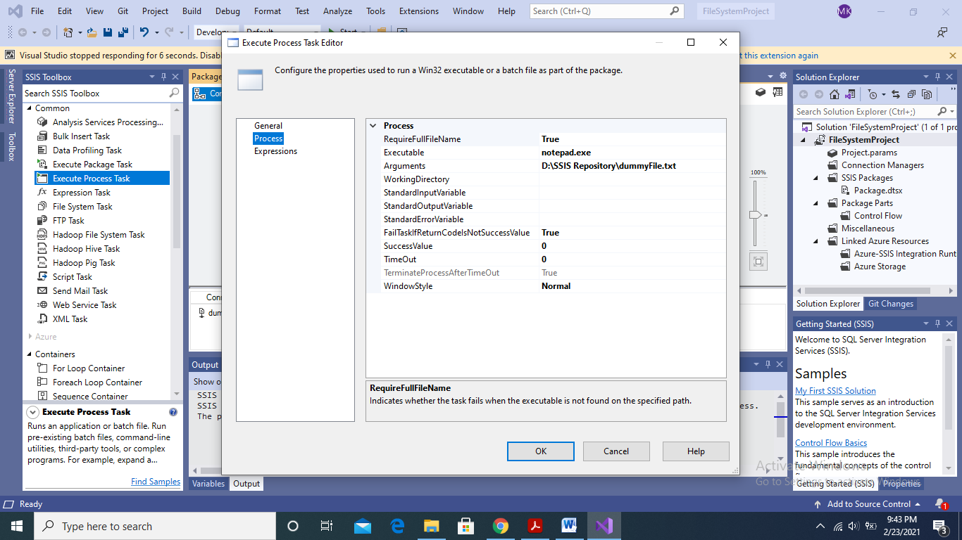

4. Click Ok, and run the package. If there are no errors then you will see the dummyFile.txt file has been opened in notepad.

References:

[1] Knight, B., Knight, D., Moss, J. M., Davis, M., and Rock, C.: “Professional Microsoft SQL Server 2014 Integration Services”. Publisher: Wrox